Why to change the current assignment of workers

Reason 1:

Suppose that the demand forecast has an erratic pattern as shown in the light-blue bars of the chart below. In an erratic forecast, demand may increase and decrease abruptly from one period to the next period. It makes sense that when the demand forecast is low, workers could be assigned to a station where they have little experience. It also makes sense to reassign workers to the stations where they have achieved the highest learning when demand increases.

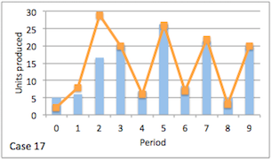

Figure 1: An erratic demand forecast vs. the actual production of the assembly line

Light-blue bars represent the demand forecast.

Orange line represents the actual number of units produced by the assembly line.

Reason 2:

The learning rate of a worker is faster than the learning rate of the immediate downstream worker. In this case worker with the faster learning will be accumulating work-in-process (WIP) inventory for the downstream station. After a few periods, it seems reasonable to switch both operators in order to make the faster worker reduce to number of jobs accumulated.

Reason 3:

Suppose an increasing demand pattern where the assembly line has to produce progressively more and more units every period. Workers have remained on the same station for several periods, taking advantage of learning, and producing inventory of finished goods. (The learning rate is fast enough so as to meet the demand forecast and even allow accumulation of inventory.) So far, a lost sale has not occurred, and just a few more periods remain to conclude the planning horizon. If workers continue on the same station, more inventory of finished goods will be accumulating, leading to unnecessary inventory at the end of the planning horizon. Thus, on the last few periods, it makes sense to change the position of workers in order to force a decrease in the rate of accumulation of inventory.